Term Project Part-1

The Quaternary Geology and Regional Analysis of The Abitau Lake Area, Northwest Territories.

Arman Kanorwalla

Student ID: 20899832

**Introduction**

The Abitau Lake area, as delineated by the map boundaries of 106°00’00’’W to 108°00’00’’W and 61°00’00’’N to 60°00’00’’N, presents a rich tapestry of geological and physiographic features that offer a window into the region's climatic and glacial history. It's situated Just above the northern border of Saskatchewan and approximately 440 km southeast of Yellowknife, it lies within the vast expanse of the Rae Province, part of the larger Churchill Province of the Canadian Shield. This region of the Canadian Shield is lauded for its venerable geological structures and varied landscapes, characterized by a rugged terrain punctuated with numerous lakes and extensive boreal forests, all under a sparse population and harsh winter climates.

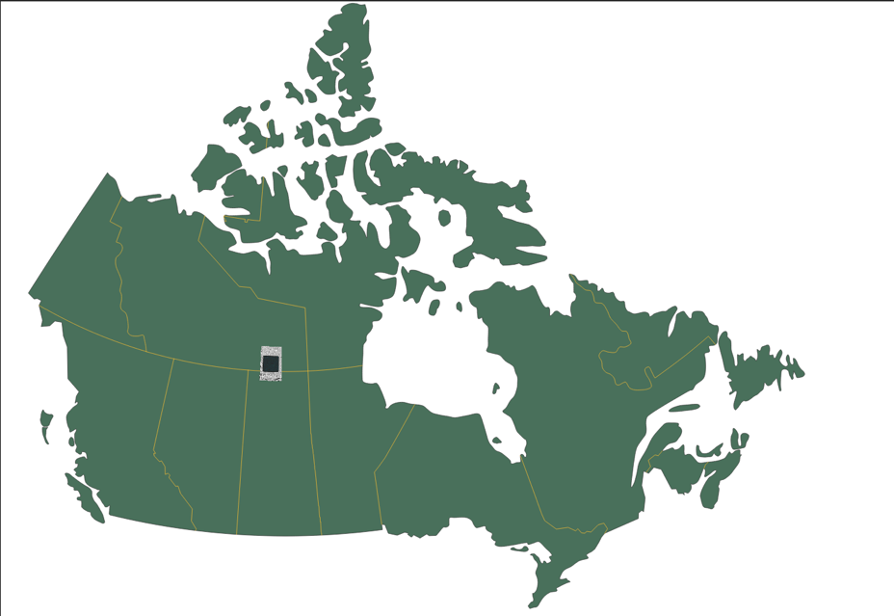

Figure1. The black box outlines our map area.

Notable features near our map area are Lake Athabasca to the southwest and the impressive Great Slave Lake to the northwest. Our interpretations from part 1 have brought to light the physiographic features, marked by an excessive drift cover including drumlin fields and parallel esker systems, which indicate a rich history of glacial activities. The 14 parallel subglacial meltwater corridors, with their distinctive deposits of hummocky glaciofluvial and terraced glaciofluvial materials, alongside hummocky till, underline the dynamic glacial processes that have sculpted this landscape. This thin till, a hallmark of the map area, is an eloquent testament to the extensive glacial history that has dominated the region.

The terrain is covered by a variety of surficial deposits that have been categorized based on their age and genesis. The Quaternary (Holocene) period features two distinct groupings: alluvial sediments (purple colour in Figure 2.) which include plains, fans, and terraced formations, and organic undifferentiated deposits (grey colour in Figure 2.). Evidence of the Last Glaciation (Wisconsin) is present in our map area through glaciolacustrine, glaciofluvial, and general glacial deposits.

The pre-Quaternary period, spanning from the Archean to the Paleoproterozoic eras, is represented solely by bedrock, which forms the foundational geological layer of the area. This bedrock outcrops, predominantly in the west and sporadically to the east, along with the homogenous thin till that overlays much of the area

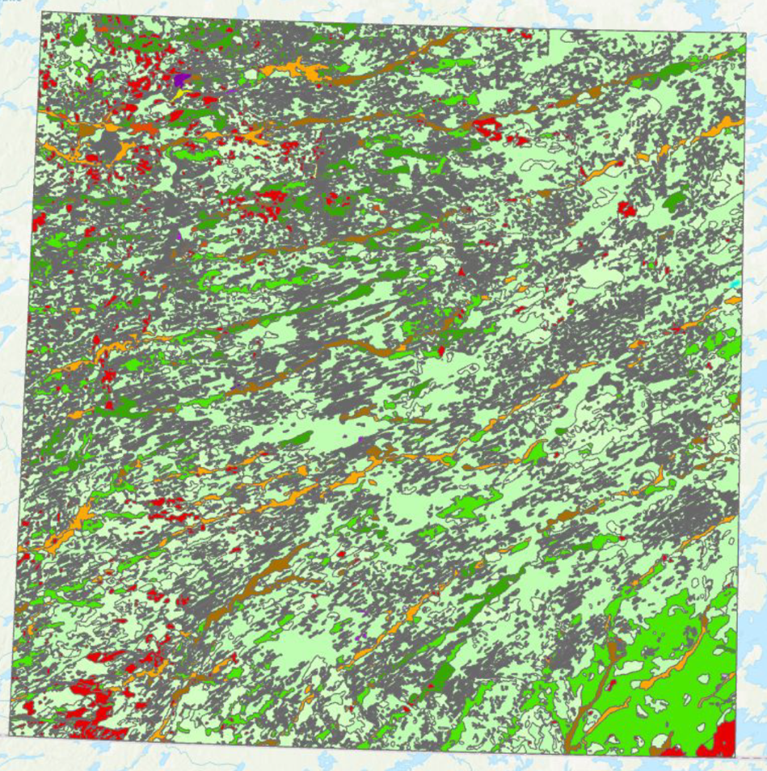

Figure 2. shows the superficial geology of the map area.

The new dataset for the Abitau Lake map area focuses on geochemical analysis through Inductively Coupled Plasma Mass Spectrometry (ICP-MS). This technique has provided detailed data on the elemental composition of samples from the region. The dataset is extensive, with the data being delivered in Excel spreadsheet format (with .xlsx extensions) and accompanied by PDF files that explain the testing methods and the geographic locations of the samples.

**Objective:**

The primary focus of the current analysis is on the elemental percentages obtained from the ICP-MS data. These percentages provide a clear indication of the relative abundance of certain elements within the samples, offering a quantitative perspective on the area's geochemistry. This data, when analyzed, can reveal patterns of glacier movement.

Objectives for the Abitau Lake Area Quaternary Geology Analysis:

* ***Geochemical Profiling:*** Analyse ICP-MS data to determine elemental abundances and patterns indicative of historical glacial activity and geochemical processes.
* ***GIS Integration and Visualization:*** Integrate geochemical and sediment distribution data into QGIS, creating detailed maps for visual analysis and interpretation.
* ***Sediment Distribution Analysis:*** Utilize QGIS to interpret sediment patterns, contributing to an understanding of past environmental conditions and sedimentary processes.
* ***Geological Context Interpretation:*** Contextualize geochemical concentrations within the broader geological framework, linking local data with regional geologic phenomena.

**Methodology**

For this part, we make use of the following tools and datasets to complete our analysis:

**Geochemical Data for Lake Sediments and Surface Waters, Abitau Lake Area from the GEOLOGICAL SURVEY OF CANADA. (McCurdy et al., 2016)**

In 2015, a regional geochemical survey of lake sediments and surface waters was conducted in the Abitau Lake map sheet (NTS 75-B), southeast Northwest Territories. This report includes data from 407 sites, covering 65 elements in lake sediments (analyzed using aqua regia digestion) and 65 elements in waters (McCurdy et al., 2016). For our analysis, we will only be taking a look at the lake sediment data.

Sample site targets (as seen in Figure 3) were preselected using digital means and then uploaded to a GPS unit (McCurdy et al., 2016). Upon reaching the sample sites, field observations were recorded digitally on a tablet using a standardized form (McCurdy et al., 2016).

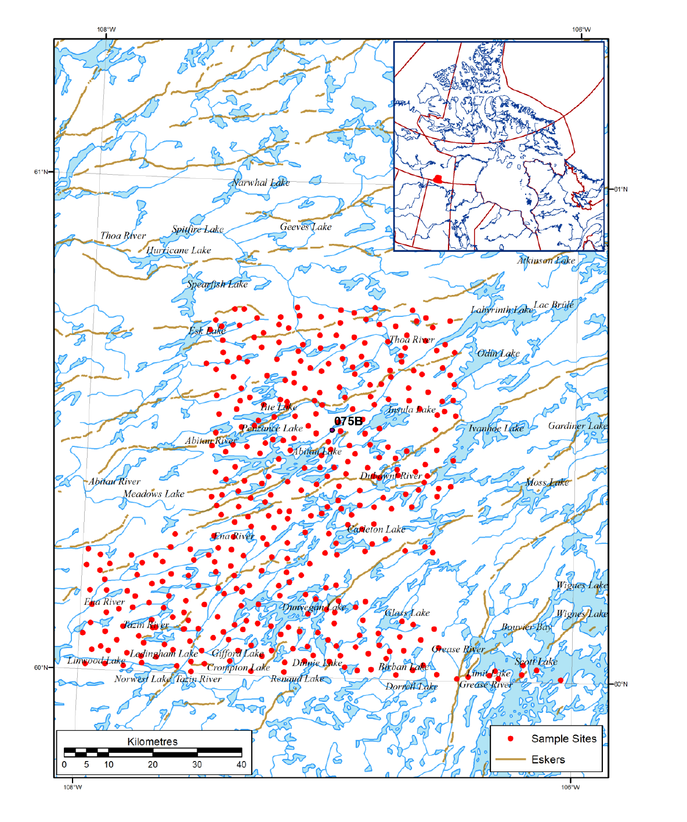

Figure 3. shows the preselected sample sites.

A specialized hollow-pipe sampler, equipped with a bottom valve (as shown in Figure 4), was employed to collect the lake sediments (McCurdy et al., 2016). This sampler, when dropped into the lake from a platform attached to the helicopter's landing skid opposite the pilot, could penetrate the lake bottom sediments to an optimal depth (McCurdy et al., 2016). Approximately one kilogram of wet lake sediment, known as gyttja, was collected in each sampling effort (McCurdy et al., 2016).

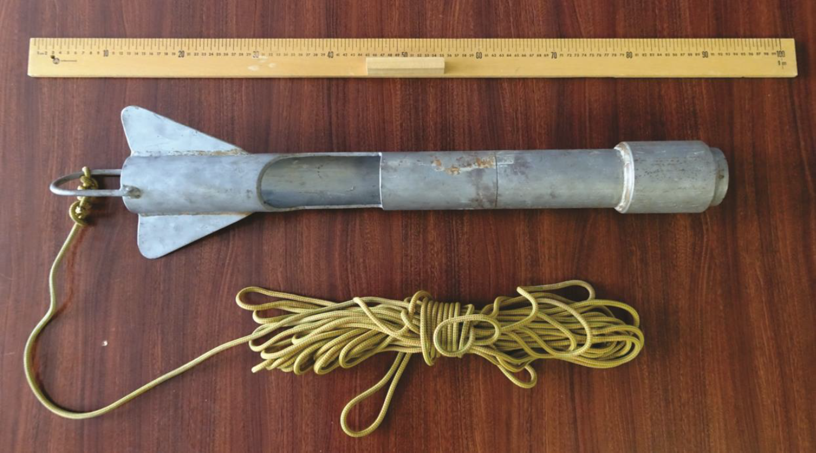

Figure 4. Specialised sampler used to collect lake sediments.

The samples were air-dried, crushed, and then sieved through an 80 mesh (177 μm) screen to prepare for analysis (McCurdy et al., 2016). After this an Inductively Coupled Plasma Mass Spectrometry (ICP-MS) analysis was done on the prepared samples and the data was presented to us in an Excel sheet (McCurdy et al., 2016).

The ICP-MS lake sediment data includes the following details:

* Unique ID for each data entry
* Sample Number to track and reference specific samples
* Sample Type, categorizing the nature of the sample (such as rock, sediment, water, etc.)
* Geospatial coordinates are given in Latitude and Longitude (NAD83)
* Easting and Northing coordinates (UTM Zone 13), providing precise location data in a grid-based system
* Quantitative elemental data, expressed in parts per million (PPM) or parts per billion (PPB), with some elements detailed in percentages alongside their detection limits

For quality assurance, the samples were organized into consecutively numbered blocks of twenty. Within each sequence, two field duplicate samples were collected from a site chosen at the sampler's discretion (often based on ease of collection) (McCurdy et al., 2016). These field duplicates were not considered as part of our analysis as this could lead to double counting of the data and give us incorrect results.

For our analysis, we will only be looking at the following elements as they are the most abundant in the samples that were collected and tested.

Elements focused on:

* Aluminium
* Calcium
* Iron
* Potassium
* Magnesium
* Sodium
* Phosphorus
* Sulphur
* Titanium

**QGIS (Quantum GIS):**

* Initial sediment collection points were carefully plotted on the map sheet within QGIS, ensuring each sample's location was georeferenced with precision. This step was essential to establish a baseline for the spatial distribution of the collected samples, allowing for a clear visual representation of where each geochemical snapshot was taken.
* Once the points were established, concentration circles were generated at each sample location to visually depict the varying levels of elemental concentrations. The size and colour intensity of these circles were scaled proportionally to the concentration values, providing an immediate visual cue to the distribution and intensity of geochemical signatures across the region.
* By examining the spatial relationships and gradients represented on the map, we could infer the geological processes that contributed to the current geochemical landscape.

**Various Research Papers and Lecture Content:**

Integrated for the interpretative phase of the assignment, leveraging these sources to describe the geological history and regional processes in proximity to or within the analysis area.

**Analysis of the dataset on the Map Sheet:**

We will be taking a look at the concentration maps of each element of the elements stated above and analysing them.

*Aluminium (Al):*

Aluminium, known for its lightweight properties, holds the title of the most abundant metallic element in the Earth’s crust. It is commonly encountered within clay minerals and feldspars and is a component of compounds that are found to some extent in nearly all rocks, vegetation, and animals. In the region studied, aluminium exhibits a fairly even distribution.

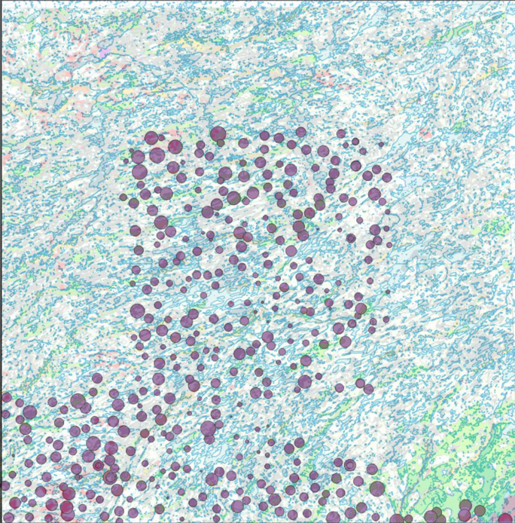

Figure 5. shows the concentration distribution of Aluminium (purple circles) across our map area.

*Calcium (Ca):*

Calcium, an alkaline-earth metal, is the fifth most abundant element in Earth's crust. It is widely found in a variety of silicates and aluminosilicates, in salt deposits, and dissolved in natural waters, as well as constituting a part of the shells of marine animals. Notably, the highest concentration of calcium in the region is observed in the southwest corner

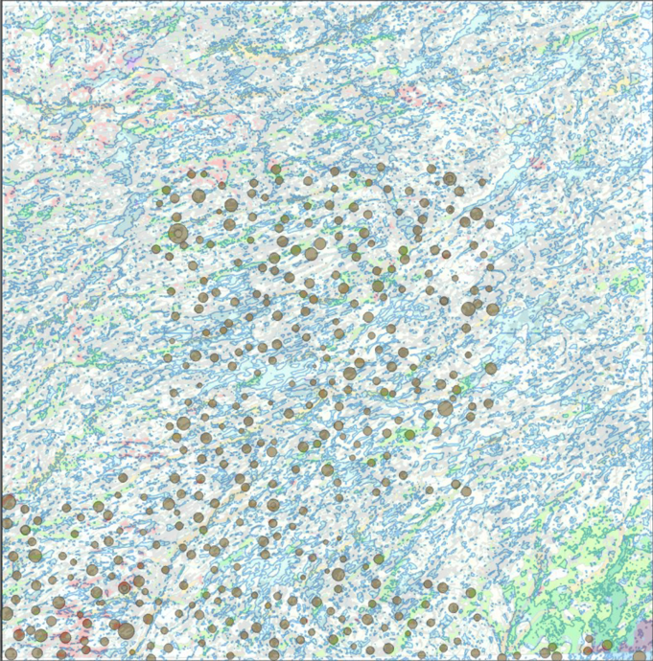

Figure 6. shows the concentration distribution of Calcium (brown circles) across our map area.

*Iron (Fe):*

Iron, which stands as the most abundant element on Earth by mass, typically occurs in iron oxide and hydroxide forms, often embedded within clay deposits. The distribution of iron in the region aligns with the flow direction of ancient glaciers, particularly to the southwest.

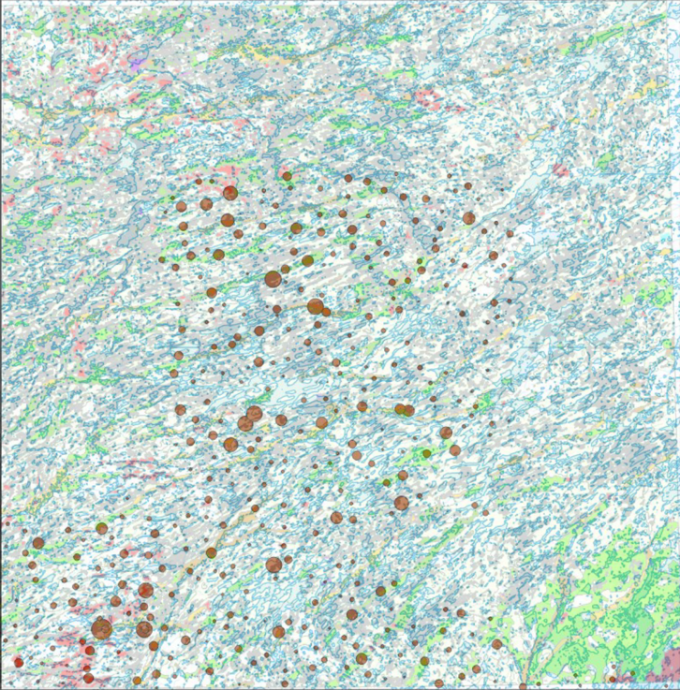

Figure 7. shows the concentration distribution of Iron (brown circles) across our map area.

*Potassium (K):*

Potassium is a soft metal known for its rapid reaction with atmospheric oxygen. It is commonly found within feldspar minerals, such as orthoclase and plagioclase, which frequently are major constituents of sand. In the region under examination, the southeast corner is distinguished by the highest concentrations of potassium (K).

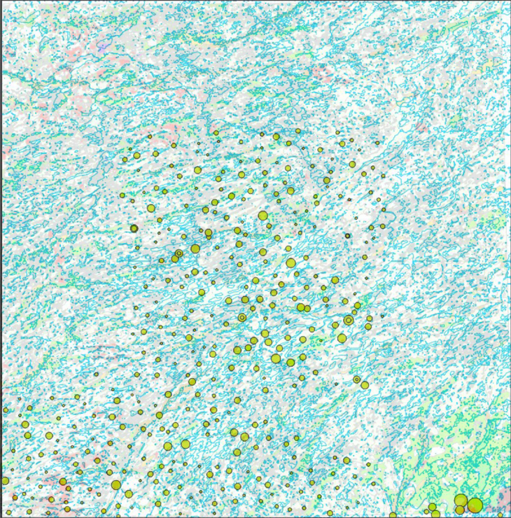

Figure 8. shows the concentration distribution of Potassium (yellow circles) across our map area.

*Magnesium (Mg):*

Magnesium, classified as an alkaline-earth metal, holds the distinction of being the lightest structural metal. Within the region of interest, the highest magnesium (Mg) concentrations are found in the southwest and southeast corners.

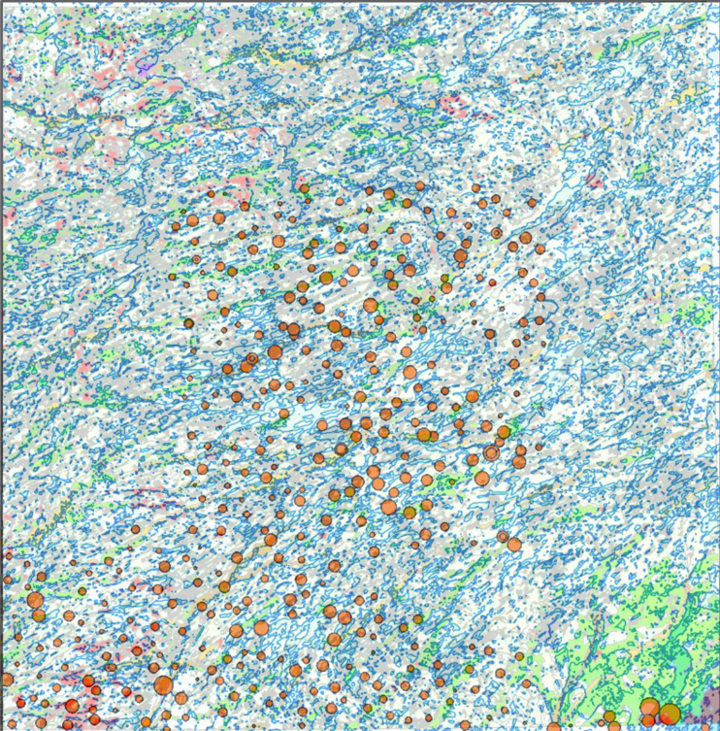

Figure 9. shows the concentration distribution of Magnesium (orange circles) across our map area.

*Sodium (Na):*

Sodium, characterized as a light and highly reactive metal, is predominantly found within feldspar minerals such as orthoclase and plagioclase, which often form integral components of sand. The geochemical landscape of the region reveals that the highest concentrations of sodium (Na) are located in the southwest and southeast corners (as seen in Figure 10).

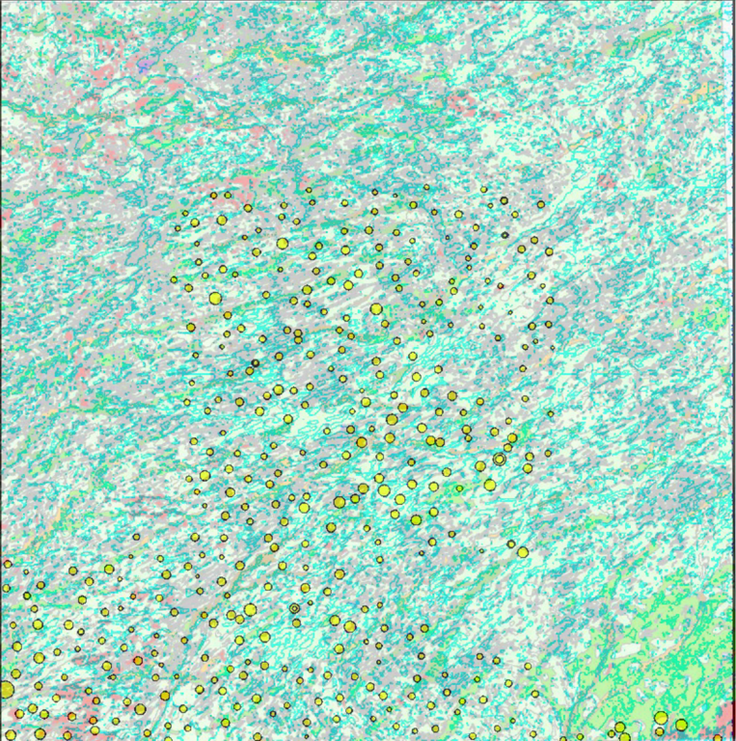

Figure 10. shows the concentration distribution of Sodium (yellow circles) across our map area.

*Titanium (Ti):*

Titanium, a heavy metal element, is typically found within heavy minerals like zircons, commonly located in sandy environments. In the map area, titanium distribution exhibits notable concentrations primarily in two regions: at the centre of the sampling zone and markedly so in the southeast corner (as seen in Figure 11).

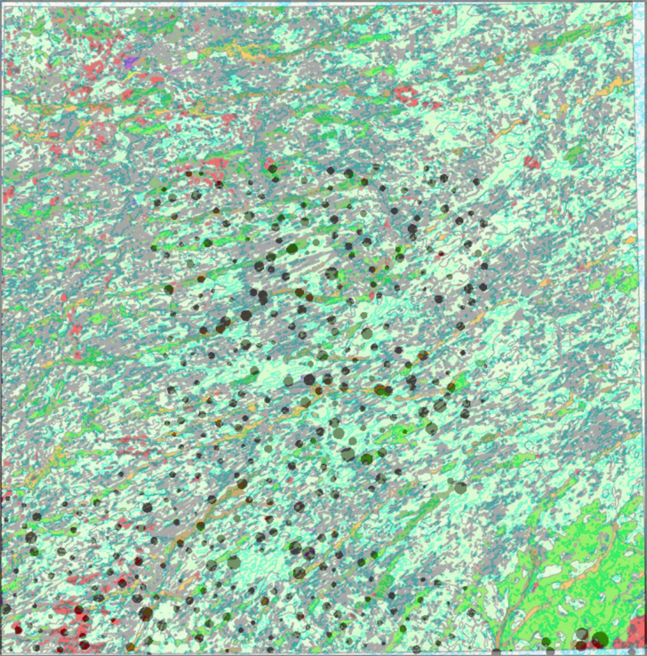

Figure 11. shows the concentration distribution of Titanium (dark green circles) across our map area.

*Phosphorus (P):*

Phosphorus, a vital element for life, manifests predominantly in the centre of the region, potentially indicating the presence of phosphorus-rich geological formations such as apatite—a group of phosphate minerals including fluorapatite, chlorapatite, and hydroxylapatite, commonly found in igneous and metamorphic rocks. This central concentration could also derive from the accumulation of organic material, as phosphorus is integral to numerous biological processes.

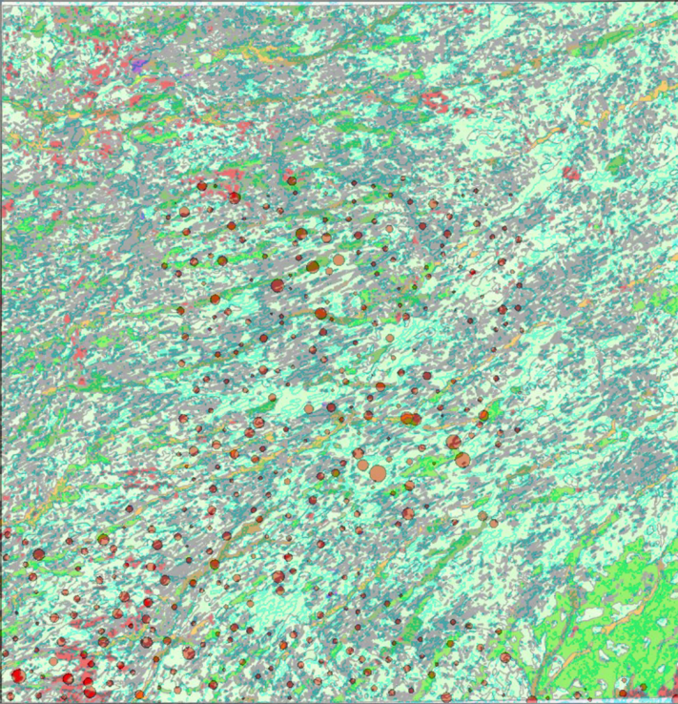

Figure 12. shows the concentration distribution of Phosphorus (orange circles) across our map area.

*Sulphur (S):*

Sulfur, a nonmetallic element recognized for being one of the most reactive elements, is present in minimal amounts in the area studied. Due to its scant concentration, sulfur was not included in the superimposition analysis

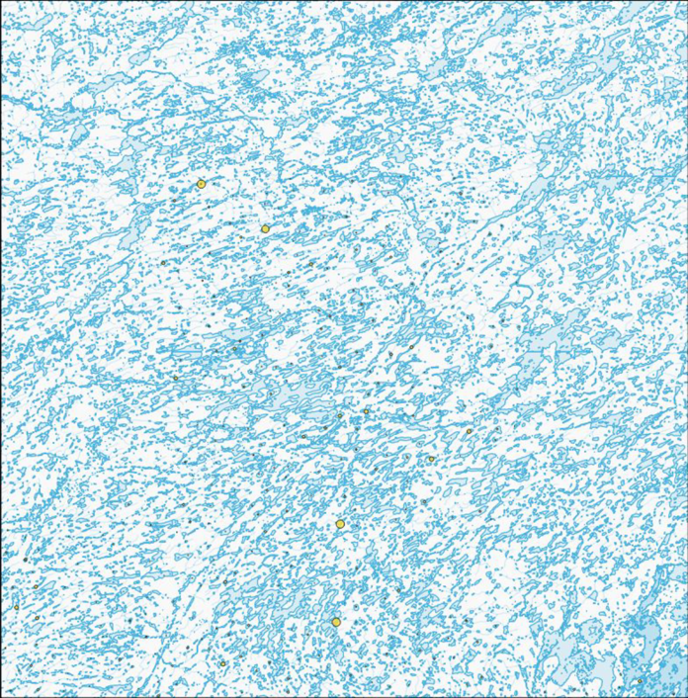

Figure 13. shows the concentration distribution of Sulphur (yellow circles) across our map area.

Table 1. Shows each respective element's concentration data.

|  |  |  |
| --- | --- | --- |
| Element | Average concentration in region | Range of concentration seen in the region |
| Aluminium (Al) | 1.45% | 0.4% - 2.08% |
| Calcium (Ca) | 0.45% | 0.2% - 1% |
| Iron (Fe) | 1.91% | 0.5% - 29.46% |
| Potassium (K) | 0.0451% | 0.05% - 0.025% |
| Magnesium (Mg) | 0.095% | 0.05% - 0.36% |
| Sodium (Na) | 0.011% | 0.005% - 0.033% |
| Titanium (Ti) | 0.0205% | 0.01% - 0.075% |
| Phosphorus (P) | 0.291% | 0.1% - 0.595% |
| Sulphur (S) | 0.34% | N/A* |

*sulphur does not show a range as it is detected in very few sampling sites.

**Interpretation:**

The map area, embedded within a geologically diverse landscape, has been shaped by complex natural histories resulting in a variety of soil and rock formations. While the analysis did not reveal any alluvial deposits, this absence is attributable to the scope of sampling which bypassed the areas typically rich in such deposits. The emphasis, instead, was placed on examining other types of deposits, such as organic undifferentiated deposits, glaciolacustrine sediments or till, and notably, peat. Peat is found in several forms within this area, predominantly as fibrous organics, soft muck, and in bogs and fens, indicating regions with significant surface or groundwater influence and a history of organic matter accumulation and preservation.

Elevated elemental concentrations in the map's southwestern quarter suggest that during the Last Glaciation, ice flowed in a southwest direction. This elemental arrangement is in harmony with the known ice movement patterns and suggests that glacial dynamics were a major force in the elemental deposition across the region, a factor still evident in its current geological structure.

The map area's foundational geology is marked by Archean-aged Granite Gneiss from the Churchill Province, signifying a past replete with tectonic and metamorphic activity. Granite intrusions and signs of extensive deformation in the bedrock are the legacies of these ancient forces. Moreover, the landscape bears the imprint of the Laurentide ice sheet's southwestward movement during the last glacial period, a factor that has significantly shaped the terrain and influenced the distribution of geological materials. The melting of this ice sheet led to basal sliding, regelation intrusion, subglacial sediment deformation, and internal deformation across the region.

**Conclusion:**

In conclusion, the elemental analysis conducted corroborates the hypothesized ice flow chronology initially proposed. It suggests that the elements we concentrated on were deposited in their respective locations due to glacial movements. Nonetheless, our data is not without its limitations. Not all sections of our map sheet were subject to sampling, and extending the sampling coverage could substantially refine our understanding and interpretation. Additionally, the sulfur distribution within our map area presents an anomaly—its presence is notably abundant in only four sampling sites. Gaining further insight into the factors influencing this uneven sulfur distribution could significantly enhance our comprehension of the area's geochemical dynamics and the historical geological processes at play.**References:**

Canada, N. R. (2022). CANADIAN GEOSCIENCE MAP 350 SURFICIAL GEOLOGY ABITAU LAKE Northwest Territories NTS 75-B. Geological Survey of Canada Canadian Geoscience Maps. cgm0350_info.pdf

Government of Canada, N. R. C. (2021, March 2). GEOSCAN search results: Fastlink. Government of Canada, Natural Resources Canada, Corporate Management and Services Sector, Chief Information Officer Branch. <https://geoscan.nrcan.gc.ca/starweb/geoscan/servlet.starweb?path=geoscan%2Fdownloade.web&search1=R>

McCurdy, M.W., Pehrsson, S.J., Falck, H., Day, S.J.A., and Campbell, J.E., 2016. Geochemical Data for Lake Sediments and Surface Waters, Abitau Lake Area, Northwest Territories (NTS 75-B); Geological Survey of Canada, Open File 8082, 1 zip file. doi:10.4095/299389

Element information was taken from: <https://www.britannica.com>